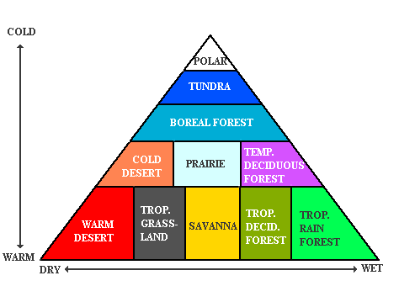

Check out the Biome Pyramid above. The pyramid on Friday’s quiz will be simpler but has the same ideas.

See if you can answer these questions:

1. Name the hottest and driest biome.
2. What do deciduous forests, grasslands, and deserts have in common?
3. Name a NONliving feature about the desert.
4. Which is forest has the most diverse trees?
5. As the temperature increases, are there more biomes closer of further from the poles?