Name______________________

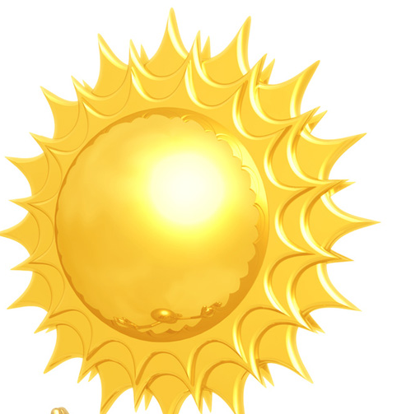
What is Weather?
30% reflected by clouds and dust
10% reflected by
the earth

“Today is will be sunny and warm with
increasing cloudiness in the late
afternoon.”

The changing condition in the atmosphere
20% absorbed
by atmosphere
40% absorbed by the earth
(The layer of air that surrounds the earth) is
called weather.
Weather is caused by the uneven heating of the
atmosphere. For example, where the sun’s rays
strike the earth at a slant, the earth is heated less
than where the sun’s rays strike directly. Also,
water and land absorb hear and cool off at different rates.
Energy from the sun, called solar energy, causes weather. Look at the picture. What happens to the sun’s energy?

1. Using the information from the picture, complete the circle graph to indicate what happens to the sun’s energy. Use colored pencils.

2. Look at the picture. At which point is the earth’s surface hearted more? Why?
____________________________________________________________________________


____________________________________________________________________________
A
B

