Salem Drive School - Summer Reading
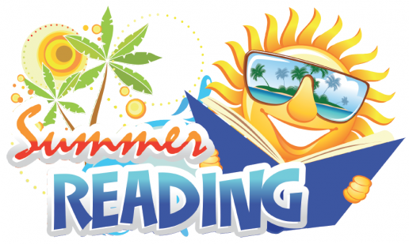

Dear Salem Drive Families,

Summer break is almost here! With so many exciting activities to fill our summer, I hope your child(ren) takes some time to immerse themselves in books too. Reading is great fun and prevents the “summer slide.”

Students are encouraged to read any titles that appeal to them. Picture books, novel-length books, graphic novels, nonfiction books and age-appropriate magazines all provide excellent reading practice. Attempting material that is a little more challenging than they usually read is also encouraged.

If your child is interested in completing this reading log, please have them hand it in to me by September 13th for a prize. A reading log from the public library will also be accepted in lieu of the Salem Drive reading log.

Best wishes for a happy summer,
Mrs. Pedalino

Salem Drive School’s Media Specialist

