Graphing Rainfall Name___________________________

How much does it rain in your neighborhood? Use the graph below to find out.
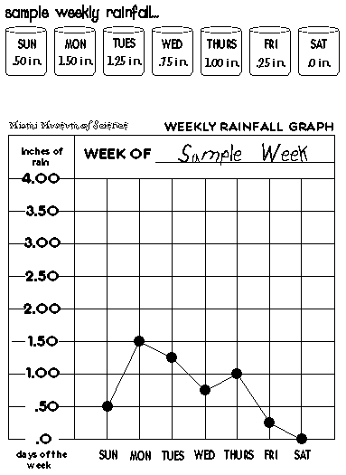

Rain clouds are made of droplets of water so small there are billions of them in a single cloud. How much rain falls during a shower, or during a day, week, or month? You can find out by measuring it with a rain gauge.

Instructions

PLACE your rain gauge outside.

MEASURE the amount of rain each day with your rain gauge tool.

MARK the amount of rainfall for each day on your printed rainfall graph.

CONNECT the points for all days.

GRAPH the rainfall in your neighborhood for several weeks. COMPARE the amount of rain from week to week. Which month had the most rain?
