Rain Gauge Name_____________________

Instructions
- CUT out the Rain Gauge Ruler.
- COVER the ruler with clear cellophane, front and back. This will protect it from the rain, and make it sturdy so that the ruler can stand straight.
- STAND the ruler inside the glass container so that the ruler rests on the bottom of the container.
- TAPE it at the top, to the inside of the jar, so that the ruler does not fall.
- PLACE your rain gauge outside.
- MEASURE the amount of rainfall each day.

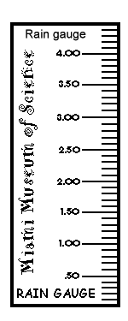
Rain Gauge Ruler

