Compound Microscope Study Guide

- Always locate an object using the- Coarse Adjustment

- Use fine adjustment- when using a high power lens

- Coarse adjustment- make sure to focus up from automatic stop

- High power- show the smallest field of view,
and most detail

- Always keep both eyes open and cover on with your hand to prevent eye fatigue

- Scanning power- shows least amount of detail

- Lens tissue- used to clean the microscope lenses

- Always center the specimen using low power

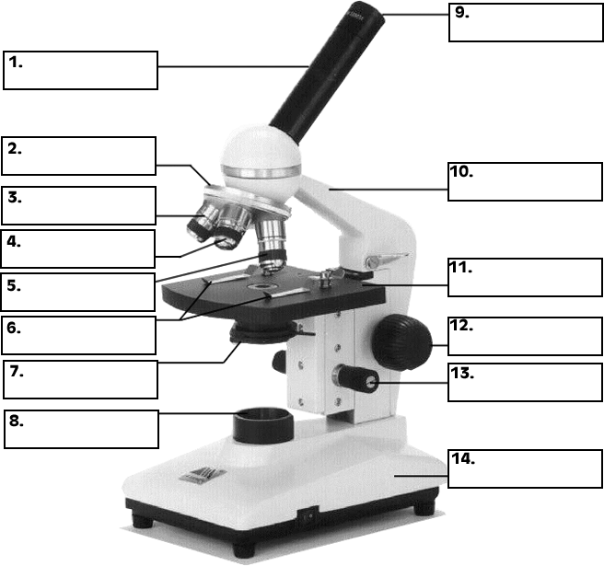

Coarse Adjustment Light Stage Clips

Ocular Lens Stage Fine Adjustment Body Tube

Iris/Diaphragm Scanning Power High Power

Low Power Revolving Nosepiece Arm Base

