Skills Worksheet
Section Review
The Diversity of Cells
Using Key Terms
1. In your own words, write a definition for the term organelle.

2. Use the following terms in the same sentence: prokaryotic, nucleus, and eukaryotic.

Understanding Key Ideas
3. Cell size is limited by the
a. thickness of the cell wall.
b. size of the cell’s nucleus.
c. cell’s surface area–to-volume ratio.
d. amount of cytoplasm in the cell.
4. What are the three parts of the cell theory?

5. Name three structures that every cell has.

6. Give two ways in which archaea are different from bacteria.

Section Review continued
Critical Thinking
7. Applying Concepts You have discovered a new single-celled organism. It has a cell wall, ribosomes, and long, circular DNA. Is it a eukaryote or a prokaryote cell? Explain.

8. Identifying Relationships One of your students brings you a cell about the size of the period at the end of this sentence. It is a single cell, but it also forms chains. What characteristics would this cell have if the organism is a eukaryote? If it is a prokaryote? What would you look for first?

Interpreting Graphics
The picture below shows a particular organism. Use the picture to answer the questions that follow.
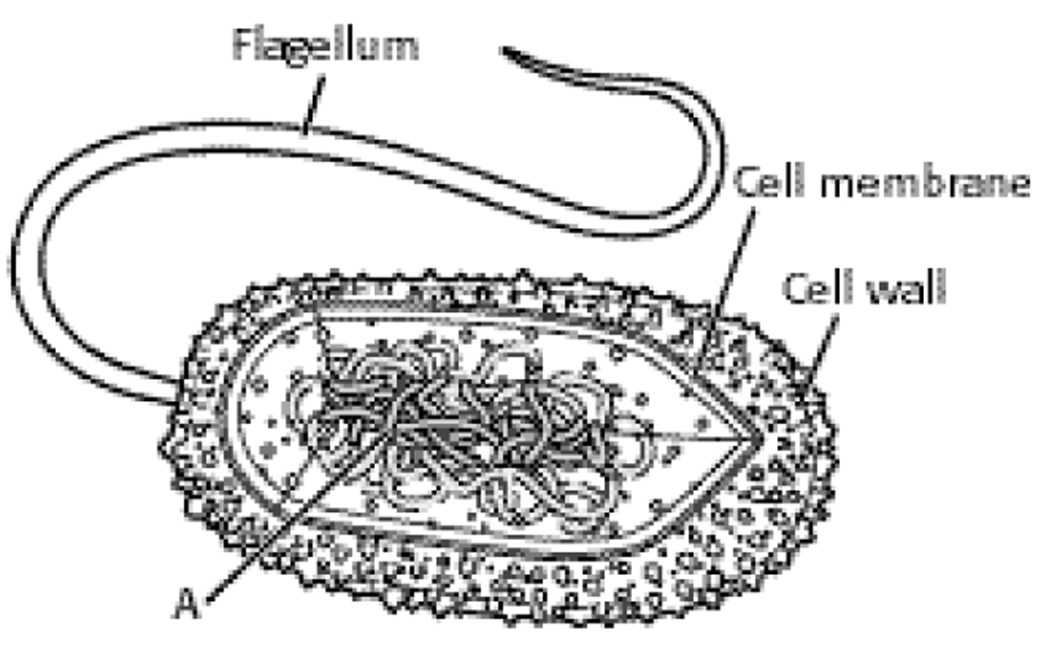
9. What type of organism does the picture represent? How do you know?

10. Which structure helps the organism move?

11. What part of the organism does the letter A represent?

